St. Margaret of Scotland Anglican Church

Open minds and loving hearts
All are Welcome

Trinity Sunday
June 7, 2020

Announcements

St. Margaret of Scotland Mission Statement:
To be a Christ-centered, mission minded community embracing all people across the spectrum of cultural, ethnic, racial, gender, sexual orientation, ages and class diversity as full members of the family of God.
TODAY we are meeting for our service of Morning Prayer on Zoom. The link to our service is: https://us02web.zoom.us/j/9024552451
Or you can go to Zoom.us and click Join a Meeting at the top of the homepage and use the meeting ID 902 455 2451 (same as our church phone number)
If you have a long-distance plan, you can also phone in to the service by calling 1 438 809 7799 (Montreal) and entering the Meeting ID number.

The virtual doors will be open anytime after 10:00 AM so you can come early and chat with folks before the service. Likewise you may linger and chat afterwards in a virtual coffee hour.

If all goes according to plan the service will also be available to watch on Facebook Live, and will be available after the fact by following the link on our parish website or Facebook page.

I am sorry to say that we will soon be saying farewell to our music director Emanuel Serra. Emanuel is feeling the need to be reunited with his wife and two little girls in Korea, and has given us his three months notice. We are sorry to see him go, but we certainly understand his decision. The wardens and I have already begun the process of looking for a new music director for St. Margaret of Scotland. Please keep us in your prayers.

I am not the only one retiring from full time ministry this summer. Archbishop Ron Cutler will be retiring as of August 1st. Until a new bishop is elected a committee of three clergy will be appointed to take care day to day administrative responsibilities.
The Electoral Synod to discern whom God is calling as our next Diocesan Bishop will be held on Saturday, September 12. Please keep in your prayers the four candidates who have allowed their name to stand: The Rev. Katherine Bourbonniere, The Rev. Carl Frazer, The Rev. Sandra Fyfe, and The Rev. Elliott Siteman, as well as our own Synod reps, Lilo Sawh and Frank Riggs. Charles

Day by Day The May/June/July issue of this daily devotional has arrived and there are still several copies at the back of the church. If you normally take one or know of who does, please let me know and we'll see that people get them somehow. Charles

Although St. Mark’s Food Bank is not receiving food donations currently, the Food Bank is still active and very much in use. In lieu of food donations, they would welcome donations of $25.00 gift cards for Superstore, Scobey’s or Walmart. Your donations may be placed in a sealed envelope addressed Attn: Rev. Nichola Fish-Cumine and placed in the secure mail slot on the Russell Street side door of St. Mark’s at any time. This mailbox is checked regularly.

Thanks to Community Garden committee members who have cleaned up in the Memorial Garden and have planted vegetables for St. Mark’s Ward Five Food Bank using the rectory raised bed. If you would like to help in the garden, please speak to Margery or Georgia.

Compline continues every Tuesday, Wednesday and Thursday evening at 9:00 pm on Zoom. So far 14 different people have joined us for this and the average attendance is around seven. Anyone from St. Margaret's or beyond is welcome to take part. The Zoom Meeting ID # is the same as the church phone number: 902 455 2451.

Our Youth Group has been meeting regularly on Zoom at 6:00 pm on Sunday evenings and they really appreciate this opportunity to
connect with each other. Thanks to Jade Osborne and Blake Wright for their help with this ministry.

Denine, our Parish Secretary, is continuing to work from home on Tuesdays, Wednesdays and Thursday, updating the Parish website, putting together Sunday bulletins, and doing other work asked of her. She may be reached at the parish email address, st.mofs@gmail.com

Parish Calling Ministry thank you to those who have volunteered to call members of the congregation just to check in, and keep in touch and see how everyone is doing. I have divided up the parish list alphabetically and I have asked those who were calling to use their judgment as to how often call the 10 or so people assigned to them.
Initial reports are that these calls are very much appreciated.

Our Services Next Sunday June 14th is The Second Sunday after Pentecost.
For those who would like to have a look at the readings ahead of time they are:
Genesis 18:1-15; Psalm 116:1, 10, 17;
Romans 5:1-8; Matthew 9:35-10:8-23.

From the Book of Remembrance

Today we remember on their Year's Mind
Francis Fredericks – June 7
Augustus Meade – June 7
Maxwell Kettle – June 10
Helen Adams – June 11

Rest eternal grant unto them O Lord.
And let light perpetual shine upon them Amen.

Word form the Brothers: SPEAK
The Spirit that Jesus gives empowers us to speak the truth, and to speak it boldly. Witness the fearlessness of the disciples after they receive the power of the Spirit. They cannot be shut up! They cannot be intimidated by threats of punishment or death. Their hearts are burning within them, and they cannot keep silent. They know that, no matter how intimidating their audience, they need not fear.
-Br. David Vryhof
Society of Saint John the Evangelist

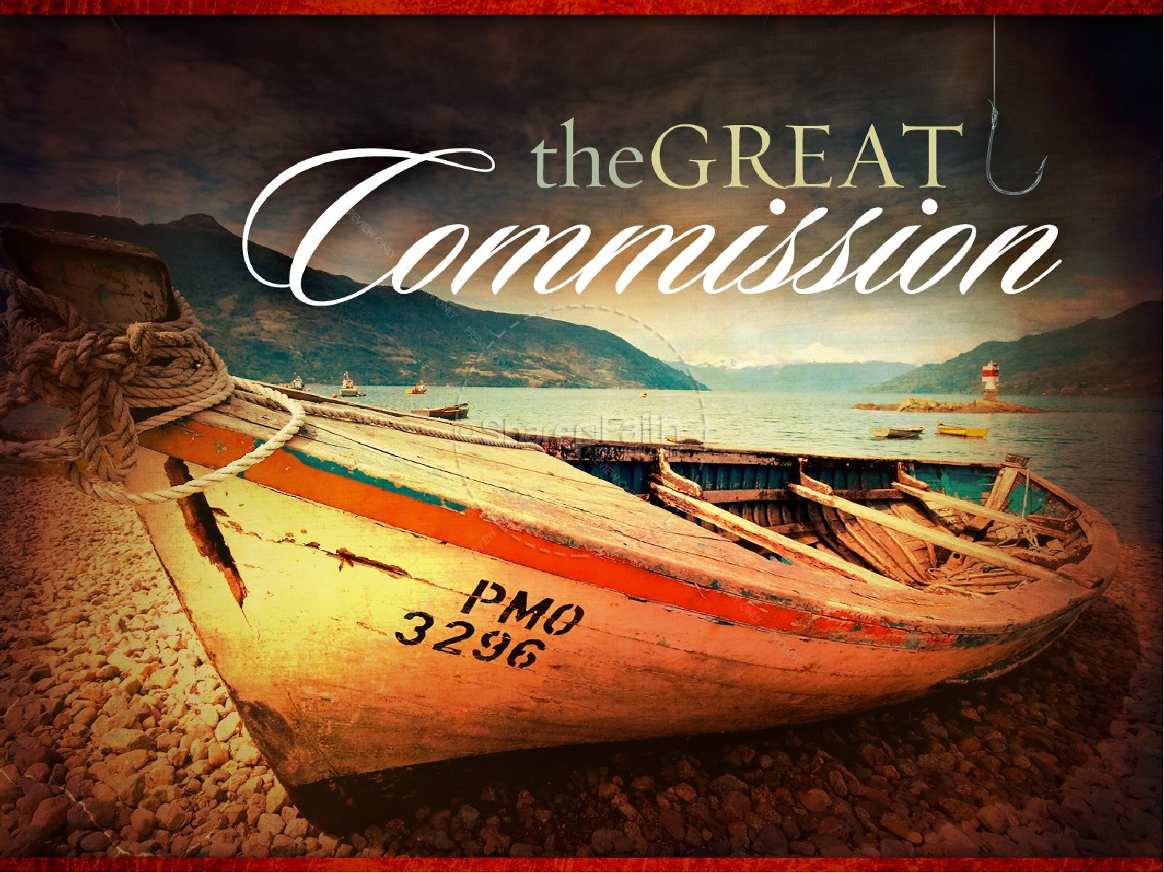

The Anglican Church of Canada
Diocese of Nova Scotia and Prince Edward Island
Bishop & Metropolitan:
The Most Rev. Ron Cutler
Rector: The Rev. Canon Charles Bull
email: charlesbull97@gmail.com
Music Director: Emanuel Serra 902-809-9753
Wardens: Brian George 902-220-8037
Dale Moffat 902-835-6948
Licensed Lay Ministers: Bruce Hollett,
Donna Mossman, Ruth Rogers and Sherry Smith
Church Secretary: Denine Mitchell
Office Hours By Phone: Tuesday, Wednesday & Thursday 1– 4 pm
Church Office and Rectory Phone 902-455-2451
st.mofs@gmail.com - Email
checked during office hours
www.stmargaretofscotland.ca
Facebook: St. Margaret of Scotland Anglican Church
Donations: www.canadahelps.org
(search: Parish of St. Margaret of Scotland Church)

